Preparation and Production of Soya sauce

Introduction

Soy sauce is one of the world's oldest condiments and has been used in China for more than 2,500 years. Naturally brewed soy sauce is made using only four basic ingredients: soybeans, wheat, salt and water. It is also made artificially through a chemical process known as acid hydrolysis.
Common soy sauce is the most widely used of the soy sauce varieties nationwide. The main manufacturing methods are honjozo (regular fermenting method), Kongo jozo (semi-fermenting method), and Kongo (mixing method). The main one of these is honjozo, the traditional method, which accounts for approximately 80% of production. Other methods are Kongo jozo, in which amino acid fluid and other ingredients are used in brewing to produce a unique savory taste, and Kongo, which mixes amino acids etc. to shorten the manufacturing time. In these ways, soy sauce producers add new technological ideas while maintaining old traditions, to make products that are always of stable quality.
Today soy sauce is made by two methods: the traditional brewing method, or fermentation, and the non-brewed method, or chemical-hydrolyzation. The fermentation method takes up to six months to complete and results in a transparent, delicately colored broth with balanced flavor and aroma. The non-brewed sauces take only two days to make and are often opaque with a harsh flavor and chemical aroma. Soy sauce has been used to enhance the flavor profiles of many types of food, including chicken and beef entrees, soups, pasta, and vegetable entrees. It’s sweet, sour, salty, and bitter tastes add interest to flat-tasting processed foods. The flavor enhancing properties, or umami, of the soy extract are recognized to help blend and balance taste. The condiment also has functional preservative aspects in that its acid, alcohol, and salt content help prevent the spoilage of foods.

Principle

The proteins that are the main ingredient of soybeans are broken down by the protein-breaking enzyme protease from the koji mold, to produce the amino acids that are the main constituents of soy sauce. The starch that is the main constituent of wheat is converted to glucose by the action of the enzyme amylase from the koji mold, generating sweetness and depth. The glucose is further changed into organic acids such as lactic and acetic acid by lactic acid bacteria. These soften the saltiness and bring together the taste of soy sauce. Part of the glucose is converted to alcohol by the action of yeast, heightening the fragrance. Salt-and-water solution controls the propagation of bacteria during the brewing process and acts as a preservative.
Requirement
- Soybeans grains – soak, boiled and crushed
- Wheat grains – heated at high temperature (Roasted) and crushed
- Brine water or Salt water (12-18%),
- Culture of Aspergillus oryzae or Aspergillus soyae or Saccharomyces cerevisiae
- Fermentation tray,
- Fine cloth or muslin cloth

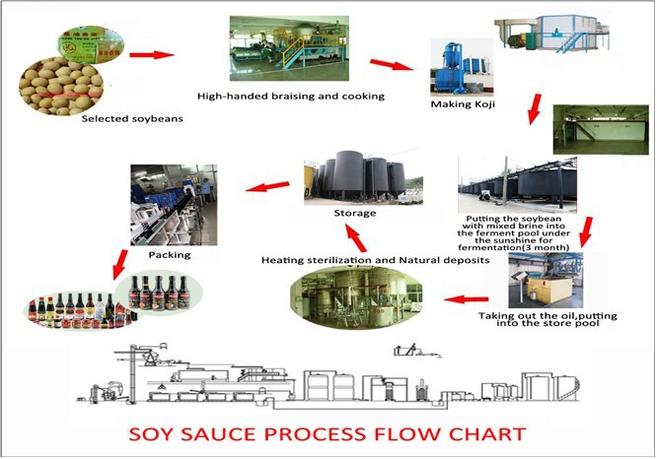

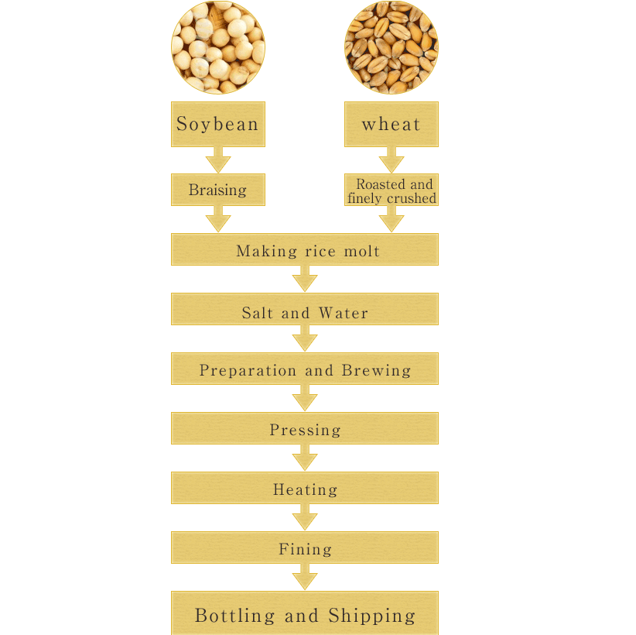
Procedure
Brewing, the traditional method of making soy sauce consists of three steps: Koji making, brine fermentation and refinement process takes 6-8 months to prepare.
- Soaking and cooking

- Soak the soybeans in salt water for at least one day or 13-15 hours.
- Change the water twice to prevent any bacteria from growing.
- Boil and steam the soybeans until cooked.
- Wheat was roasted at high temperature for at least 20 minutes and crushed.
- Koji culturing
- An equal amount of boiled soybeans and wheat flour are mixed to form a grain mixture.
- A culture of Aspergillus spores or Saccharomyces cerevisiae is added to the grain mixture and mixed or the mixture gathered spores from the environment itself. The spore culture includes-
- Aspergillus: A genus of fungus i.e. used for fermenting various ingredients, the culture is called as “Koji” in Japanese. The Aspergillus species are use for brewing soya sauce:
- Aspergillus oryzae: strain with high proteolytic activity use for brewing soya sauce mixture.
- Aspergillus tamari: this fungus is use for brewing a variety of soya sauce
- Aspergillus sojae: high proteolytic activity
- Saccharomyces cerevisiae: the yeast in the culture converts some of the sugars to ethanol which can undergo secondary reaction to make other flavors components.
- Bacillus species: these organisms likely to grow on soya sauce ingredients bring to generate odors of ammonia.
- Lactobacillus species: This organism increase acidity of feed by producing lactic acid.
- Brine fermentation

- The koji is transferred to fermentation trays, where it is mixed with water and salt to produce a mash called Moromi.
- Lactic acid bacteria and yeasts are then added to promote further fermentation.
- The Moromi must ferment for several months, during which time the soy and wheat paste turns into a semi-liquid, reddish-brown "mature mash."
- Overtime, the Aspergillus mould or Saccharomyces cerevisiae on the soya and wheat break down the grain protein into free amino acids and protein fragments & starch into simple sugar. In continuation with this, aminoglycosidic reaction gives soya sauce which is dark brown in color. A lactic acid bacterium ferments the sugar into lactic acid and yeast makes ethanol through aging and secondary fermentation makes numerous flavor compounds in soya sauce.

- Pressing

- After approximately six months of Moromi fermentation, the raw soy sauce is separated from the cake of wheat and soy residue by pressing it through layers of filtration cloth.
- The fully fermented grain slurry is placed into cloth lime container and pressed to separate solids from liquid soya sauce.
- The isolated solid part are used as Biofertilizers or feed to animals while liquid part is further process for pasteurization and refining.

- Pasteurization and refining

The raw soya sauce heated to eliminate any active yeast and molds remaining in the soya sauce and can be filtered to remove any fine particulates.

- Bottling and storage
The liquid that emerges is then pasteurized. Finally, the liquid is bottled and labeled as soy sauce.

II. MISO (Bean paste)
Miso is the Japanese name given to paste like products made by fermenting cereals, soybeans and salt with mould, yeast and bacteria. Bean paste has consistency of peanut butter, some smooth and some crunchy and its color varies from light yellow to reddish brown.
Categories of Miso
According to ebine, Japanese Miso is categorized into 3 major types based on raw materials used.
- Rice Miso: Rice+ Soybeans+ Salts
- Barley Miso: Barley+ Soybeans +Salts
- Soybean Miso: Soybeans+ Salts
These three types are further categorized on the basis of taste as under
- Sweet Miso
- Medium salty Miso
- Salty Miso
Each of these groups again divided into three groups as
- White Miso
- Light Yellow Miso
- Red Miso
- Raw materials
Procedure
Raw materials
- Soybeans are washed, soaked in water about 20 hours at 16⁰C and drained
- The soaked bean are then cooked in water or steamed at a temperature of 115⁰C for about 20 minutes in closed cooker.
Koji preparation
- Polished rice is soaked in water at 15⁰C for overnight or until moisture is about 35%.
- Excess water gets drained off and soaked rice is steamed at atmospheric pressure for 40 minutes.
- Tane koji means spores of bacteria, yeasts and moulds is sprayed over the rice and mixed well. Mainly with Aspergillus oryzae
- The inoculated rice is incubated at room temperature and humidity controlled room which favors the growth and enzyme production of moulds in fermentor
- Koji is removing from fermentor and mix well with salt to stop any further development of mould.

Treatment with soybeans
- Cooked soybeans are slightly get mashed and mix with salted koji and inoculated with starter culture of Saccharomyces rauxii, torulopsis, pediococcus halophilus and streptococcus faecalis.
- Well blended mixture is known as green Miso, and tightly packed in a tank for fermentation around 25-30⁰C.

Fermentation and ripening
- White miso-1 week
Salty miso-1-3 months
Soybean Miso- over a year
- During fermentation period, the green Miso is transferred from one tank to another to improve fermentation condition
- This mass is kept at room temperature for about 2 weeks to ripen.
- The ripen product is then blended, pasteurized and packaged.

III. Sufu (Bean cake)

Sufu is a soft, cheese type product made from cakes or soybean curd (tofu) by the action of mould.

Preparation of tofu:

- Soybeans are washed, soaked in water about 20 hours at 16⁰C and drained
- The soaked bean are then cooked in water or steamed at a temperature of 115⁰C for about 20 minutes in closed cooker.
- After steamed the ground mass for about 20 min and strained through a fine metal screen to separate soybeans milk from the insoluble residue.
- Curdling is achieve by addition of a coagulant such as calcium salt, magnesium salt and acids
- curd transferred to cloth lined wooden box and press with weight on the top to remove whey
- A soft but firmed cake like curd (tofu) is obtained.
- The tofu cake is cut into pieces to from cubes.
- These cubes soaked in a solution containing 6% NaCl and 2.5% citric acid for 1 hour and then subjected to hot air treatment at 100⁰C for 15 minutes.
Molding
- Tofu cubes should be separated from one another and placed in atray within pinholes in the bottom and top to aid air circulation because mycelia grow on all sides of the cubes.
- The cubes are inoculated over their surface by rubbing the pure culture of an appropriate fungus.
- The inoculated cubes are incubated at 20⁰C for 3-7 days depending on the culture.
- The freshly molded cubes known as pehtze have a luxurious growth of white mycelium and no odor.
Brining
- The molded cubes can be place in 12% salt and rice wine containing 10% ethyl alcohol.
- The immersed cubes are allowed to age about 40-60 days.
- The product is then bottled with brine, sterilized and marketed as sufu.

