### CHAPTER: III

**AMINO ACIDS AND PROTEINS**

LECTURE NOTES BY:

**SANJAY TIMANDE**

ASSOCIATE PROFESSOR AND HEAD

DEPARTMENT OF MICROBIOLOGY AND BIOTECHNOLOGY

**Genetic code**

The relationship between the sequence of amino acids in a polypeptide and nucleotide sequence of DNA or mRNA is called genetic code.

**Characteristics of Genetic Code**

**1. Amino acids are involved in protein synthesis:**

About 150 amino acids are found in nature, of which only 20 are specified by genetic code. Only these 20 amino acids take part in protein synthesis.

Some amino acids are not specified by genetic code till they are found in protein, for e.g. cystine and hydroxyproline. It is the cysteine which is incorporated in polypeptide chain during protein synthesis.

**2. Genetic code is a triplet code:**

The group of nucleotides that specifies one amino acid is a code word or codon. According to J.D. Burke genetic code is a code for amino acids.

Messenger RNA contains 4 kinds of nucleotides (A, T, G, and C) and proteins are synthesized from 20 different types of amino acids. But the basic problem regarding the genetic code was: How many bases of mRNA specify one amino acid?

The simplest possible code is a singlet code (a code of single letter) in which one nucleotide codes for one amino acid. Such a code is inadequate because it could specify only four amino acids. A doublet code (a code of two letters) is also inadequate because it could specify only sixteen (4 X 4) amino acids. Singlet and doublet codons cannot form 20 combinations which is minimum requirement to code 20 amino acids. Therefore triplet codon is necessity so that all must be coded. A triplet code (a code of three letters) could specify sixty four (4X 4X 4) amino acids. Therefore, it is likely that there may be 64 triplet codes for 20 amino acids. Genetic code is non ambiguous under normal conditions i.e. each codon specify same amino acid all the time.

Crick provided the first experimental evidence to show that genetic code is triplet code.

**3. Genetic code is non-overlapping:**

Since the mRNA molecule is a long chain of nucleotides, it could be read either in overlapping or in non-overlapping manner. The genetic code could thus be overlapping or non-overlapping.

In non-overlapping code the same base is not shared between two adjacent codons (no single base can take part in the formation of more than one codon).

It non-overlapping code , six nucleotides would spell out two amino acids while in overlapping code six nucleotides codes for four amino acids.

**Non overlapping genetic code**

Codon 1 2

…ACU AAG…

Amino acid 1 2

**Overlapping genetic code**

Codon …ACU AAG…

Amino acid 1 ACU

2 CUA

3 UAA

4 AAG

The studies on mutation show that the code is of non−overlapping type.

**4. Genetic code is commaless:**

There is no signal to indicate the end of one codon and the beginning of the next. The genetic code is commaless (or comma-free). A commaless code means that the code is without spacers or space words.

A code with commas could be represented as (X represent a base acting as comma),

UUU x GGG x UUU x GGG

Phe Gly Phe Gly

A mutation resulting in addition or deletion of base would affect only one amino acid of polypeptide chain. The total genetic message would be slightly changed.

UUU x …GG x UUU x GGG

The commaless code would not have the comma bases and can be represented as:

UUU **G**GG UUU GGG

Any mutation resulting in deletion of G would result in a drastic change in genetic message.

UUU GGU UUG GG

1961 research, Crick and colleagues also suggested that the genetic code is read as a continuous string of mRNA nucleotides uninterrupted by any kind of gap, space, or pause.

**5. Code has polarity:**

It is essential that the code must be read in fixed direction (In other words code must have polarity). If the code is read in opposite directions it would specify two different amino acids.

If the message given below is read from left to right the first codon, UUG, would specify leucine. If read from right to left the codon would become GUU and would specify valine.

The available evidences indicate that the genetic code is always read in 5' →3' direction.

UUG AUC GUC UCG

→ Leucine Ile Val Ser

Valine Leu Leu Ala ←

**6. Codons and anticodons:**

During translocation; the codon of mRNA pairs with complementary anticodons of t-RNA. Since mRNA is read in a polar manner in 5’ 🡪3' direction, the codons are also written in 5’ 🡪3' direction. Thus the codon AUG is written as 5' AUG 3'.

Codon (mRNA) 5’ A U G 3’

Anticodon (t-RNA) 3’ U A C 5’

Often, the anticodon is written in the 3' 🡪5' direction. Thus anticodon for AUG is written as 3’ U A C 5’ or UAC .The first base in the codon is at 5’ end and first base of anticodon at the 3’ end.

**7. Initiation and termination codons:**

The first amino acid along with t-RNA which is involved in protein synthesis in prokaryotes is N-Forrnylmethionyl t-RNA which binds to initiation site containing AUG codon. AUG codon is therefore called initiation codon.

Three out 64 codons do not specify any t-RNA and were hence called nonsense codons. These codon are UAA (Orche), UAG (Amber) UGA (Opal). Since they bring about termination of polypeptide chain synthesis they are also called termination codons.

Termination codons do not code for any amino acids and hence cause termination and release of polypeptide chains. No tRNA has anticodon complimentary to termination codons. Termination codons are not read by any tRNA molecules are called termination (nonsense) codons because they do not pair with any t- RNA carrying anti-codon. Termination codons are not read by any tRNA molecules but by proteins called release factors.

**8. Degeneracy of genetic code**

The genetic codons specifying the same amino acid are called degenerate codons. 61 out of 64 triplet codons are the functional codons (sense codon). Since only 20 amino acids take part in protein synthesis, it is obvious that there are many more codons than amino acid types. Only two amino acids, methionine (Met)—with the codon AUG— and tryptophan (Trp)—with the codon UGG—are encoded by single codons. The other 18 amino acids are specified by two to six codons. Codons that specify the same amino acid are called **synonymous codons.**



**Figure : Amino acids and their mRNA codons**

**9. Wobble hypothesis:**

Wobble hypothesis was proposed by Crick to explain the above.

1. Some t RNAs can read more than one codon present on mRNA.

2. Multiple codons can code for single amino acid (Degeneracy of genetic code).

**According to Wobbles hypothesis,**

1. Whenever there is codon− anticodon base pairing during translation process, the first two bases of codon on mRNA (read in 5’ → 3’) pair tightly with the corresponding bases of the anticodon. The pairing of third position bases of the codon may be ambiguous and varies according to nucleotide present in this position. Thus a single t RNA is able to recognize two or more codons differing only in third base.

The anticodon GAG of leucine ─ t RNA recognizes two codons CUC and CUU. The bonding between GAG and CUC follows the usual Watson─ Crick pairing pattern. In GAG and CUU pairing, however, hydrogen bonding takes between G and U. This is departure from the usual Watson− Crick pairing mechanism where G pairs with C and A with U. Such interaction between third bases is called “Wobble pairing”.



**Figure: Normal and Wobble Base Pairing**

1. The degeneracy of code is not random. Mostly the different codons for a particular amino acid have the same first two bases.

The third base of the codon on mRNA (read in 5′ → 3) and first base of the tRNA anticodon (first in 5′ → 3′) are called ‘wobble bases’. The pairing between wobble bases is called wobble base pairing.

As the wobble base pairing is loose, the tRNA separate from its codon easily during protein synthesis.

Codons that specify the same amino acid are called synonymous codons.

1. When only two codons specify an amino acid the third letters of the codon are either both purines or both pyrimidines
2. At the wobble position, base pairing between the nucleotides of the codon and the anticodon need not be complementary.
3. Wobble pairing takes place in only certain combinations. Following types are proposed:



**10. Deciphering of genetic codes:**

Deciphering means knowing the meaning of codons.

Following techniques used for decipherment of codons.

**A) Use of Homopolymer:**

*To determine which amino acid corresponds to the UUU codon,* Nirenberg and Matthaei synthesized an artificial mRNA containing only uracils, known as a poly (U). Then, Nirenberg and Matthaei devised an in vitro translation system composed of cellular components of bacterial translation i.e. ribosomes, charged transfer RNA molecules, and essential translational proteins. Then , they carried out twenty separate in vitro translations of poly (U) mRNA , each time using a pool of 19 unlabeled amino acids and one amino acid labelled withradioactive carbon (C14). They detected production of a highly radioactive polypeptide after conducting translation in a system containing radioactively labelled phenylalanine. The radioactive polypeptide was poly-phenylalanine (poly-Phe). Since the only possible triplet codon in the mRNA was UUU, Nirenberg and Matthaei reasoned that 5’-UUU-3’ codes for phenylalanine.

They went on to construct poly(A), poly(C), and poly(G) synthetic mRNAs and identified 5-AAA-3’as a codon for lysine (Lys), 5’-CCC-3’ as a proline (Pro) codon, and 5’-GGG-3’ as a codon for glycine.

**B) Use of heteropolymer:**

Further elucidation of the code took place by using synthetic messenger containing two kinds of bases. Khorana adapted the experimental strategy of Nirenberg and Matthaei to synthesize mRNA molecules that contained di-, tri-, and tetranucleotide repeats. His construction of repeat sequence mRNAs allowed him to define many additional codons. For example Khorana used dinucleotide repeat UC to form synthetic mRNA with the sequence.

5’-UCUCUCUCUCUCUCUC-3’

This mRNA has alternating UCU and CUC codons. Khorana identified the amino acids of the resulting polypeptide and found it contained alternating serine (Ser) and leucine (Leu).

**C) The use of trinucleotides (minimessengers)**

Nirenberg and Philip Leder developed a more direct technique for determining codons of amino acids. This technique uses cellulose nitrate filter and has been called filter binding technique.

Nirenberg and Philip Leder contributed the final piece of the genetic code puzzle in 1964 when they devised an experiment to resolve the ambiguities of codon identity remaining from Khorana’s experiments. They synthesized many different mini-mRNAs that were each just three nucleotides in length .The tiny mRNAs were added individually to in vitro translation systems containing ribosomes, along with 19 unlabeled amino acids and 1,14C-labeled amino acid, all attached to different transfer RNA molecules. The mRNA formed a complex with the ribosome and the tRNA charged with the corresponding amino acid. Each in vitro mixture was then poured through a filter that captured the large ribosome–mRNA–tRNA complexes but permitted non complexed molecules.

**11) The Genetic Code is Universal**

Biologists characterize the genetic code as almost universal i.e. every living organism uses the same genetic code to synthesize polypeptides. For example- codon AAG codes for lysine in plant, animals as well as microbes.

**Translation in Prokaryotes**

Translation is the process involving transfer of information from the genetic codes of mRNA to the sequence of amino acid forming a polypeptide or protein molecule.

In translation protein are made by ribosomes on mRNA strand.

In prokaryotes transcription and translation occurring simultaneously in the cytoplasm.

The role of tRNA and ribosome in this process was also established by Francis H Crick. This process utilizes the maximum energy resources of a cell.

**Ribosome Structure**:

Ribosomes appear as dense particles under electron microscope. Ribosomes are cellular organelles that are involved in the protein synthesis.

Ribosomes were first observed in the midst of 20th Century by George Emil Palade. Ribosomes change the instructions found in messenger RNA into the strings of amino-acids (polypeptides or proteins).

Ribosomes are ribonucleoprotein particles that contain r-RNA and proteins. In *E.coli*, ribosomes occupy 1/4th of cell mass.

In prokaryotes, ribosomes exist freely in the cytoplasm. In eukaryotes ribosomes exist freely in the cytoplasm or they may be attached to endoplasmic reticulum to give it a rough surface.

Each ribosome is made of two subunits.

In prokaryotes there is 70S ribosomewhich is composed of 50s and 30s subunits.

In *E.coli*, 30S subunit consist of 16S rRNA (1541 nucleotides) and 21 r-proteins and 50S subunit contains 23S rRNA, 5SrRNA and 31 proteins.

In eukaryotes there is 80S ribosomewhich consists of 60S and 40S ribosomal subunit. 60S subunit consists of 28S rRNA, the small 5S rRNA, 5.8S rRNA and approximately 50 proteins. The 40s subunit consists of the 18S rRNA and 33 r-proteins. (‘S’ means Svedberg’s unit of sedimentation coefficient).



**Figure: Components of prokaryotic ribosomes**

The 70S ribosome has two tRNA binding sites- P-site (peptidyl-tRNA binding site or peptidyl or polymerization site) and A-site (aminoacyl-tRNA-binding site or amino acyl or acceptor site).

During the process of translation of mRNA, a number of ribosomes attaches to one mRNA molecule, forming polyribosome, also called polysomes. A single mRNA molecule can hence be translated by several ribosomes at the same time. The mRNA is present in the gap between the two ribosomal subunits.

**Process of Translation**

The process of translation involves following steps:

1) Activation of amino acids

2) Transfer of amino acids to t-RNA

3) Initiation of protein synthesis

4) Elongation of polypeptide chain

5) Translocation

6) Chain termination

**1) Activation of Amino Acids:**

The first step in translation is activation of amino acids. Only the L- amino acids are involved in protein biosynthesis.

Each amino acid is activated by its own specific activating enzyme, called aminoacyl t-RNA synthetase to form aminoacyl adenylate (aminoacyl AMP) in presence of ATP.

In the above reaction high energy acyl bond is formed between alpha phosphate group of ATP and carboxyl group of amino acid. Beta and gamma phosphate groups of ATP are liberated as inorganic pyrophosphate (PPi). The aminoacyl AMP remain bound to activating enzyme.

Amino acids + ATP + E E-aa-AMP + PPi

Activating enzyme Activated amino acid

(Aminoacyl t-RNA synthetase) Aminoacyl adenylate synthetase (Aminoacyl AMP)

**2) Transfer of Amino Acids to t-RNA:**

There are about 100 different types of t-RNAs are found in each cell. The activated amino acid is transferred to its specific t-RNA.

E-aa-AMP + t-RNA a.a.t-RNA +AMP+E

Amino acid adenylate synthetase Aminoacyl-t-RNA

In the above reaction high energy ester bond is formed between -COOH gr. of amino acid and 3' -OH group of terminal adenosine of t-RNA.

The aminoacyl adenylate, which is attached to activating enzyme (synthetase), reacts with a specific t-RNA to form Aminoacyl-t-RNA complex. The aminoacyl t-RNA synthetase has two sites, one to recognize right amino acid and the other to recognize right tRNA. It functions in bringing the amino acid molecule and its specific t-RNA together. Similarly the t-RNA molecule has two selection sites, one for recognizing its specific aminoacyl t-RNA synthetase and the other, the anticodon, for recognizing codon on mRNA.

**3) Initiation of Protein Synthesis:**

In prokaryotes N-formyl methionine is a first amino acid which is involved in protein synthesis. N-formal methionine is formed due to addition of formyl group to the amino group of methionine due to an enzyme transformylase as follows:

Transformylase

Formyl tetrahydrofolate +Methionine ────────→ N-formylmethionine

In the above reaction formyl tetrahydrofolate is a formyl group donor.

m-RNA binds to the 30s sub-unit to form m-RNA - 30 complex. The binding of m-RNA to the 30s sub-unit requires IF-3 found in 30 S subunit. 16S ribosomal RNA (r-RNA) is involved in the binding of m-RNA to the 30 S sub-unit. Shine and Dalgarno have shown that a nucleotide sequence near the 3' – end of 16SrRNA base pair directly with the complimentary sequence in m-RNA. m-RNA molecule contain a sequence of 3 to 7 purine nucleotides preceeding the initiation codon AUG. This poly purine sequence on m-RNA pairs with complimentary polypyrimidine sequence near the 3'end of 16 S rRNA.

The activated N-formylmethionyl-t-RNA is having the anti-codon UAG. Therefore this t-RNA molecule binds to the AUG code of m-RNA. AUG codon called Initiation codon. The binding of N-formylmethionyl-t-RNA to the 30S -m-RNA complex requires IF1, IF2 and GTP. IF1 and IF2 are the initiation factors which are found in 30S sub-unit of the 70S ribosome. IF2 is required for recognition and binding of N-formylmethionyl-t-RNA to 30S sub-unit. The 50S subunit binds with 30S subunit to form 70S ribosome. When 50s sub-unit binds to 30S sub-unit, initiation factors are released from 30S subunit as well as GTP is hydrolyzed to GDP and Pi.

The m-RNA has many AUG codons. Only one of these however functions as an initiation codon. Out of many AUG one acts as initiator which has specific sequence of nucleotides near AUG.

70S ribosome has two binding sites for tRNA, the aminoacyl or acceptor site (A site) and peptidyl or polymerization site (P site) also called donor site. The P and A site are located in 50S sub-unit. Ribosome accommodates two codons at a time. P and A site accommodate one codon each. N-formylmethionyl-t-RNA binds to P site. All other t-RNAs first bind to A site and then shift to P site.

In eukaryotes the methionyl-t-RNA binds to the AUG initiation codon of m-RNA attached to 40S subunit. In eukaryotes, attachment of 60 S to 40S subunit ribosomal subunit results in formation of complete 80 S initiation complex.

In eukaryotes there is no equivalent of the prokaryotic IF-1.

**4) The Elongation of Polypeptide Chain:**

It is brought about by elongation factor (EF.) Elongation factors are of two types, EFT and EFG.

In prokaryotes EFT is of two types EF-TU (temperature unstable) and EFTs (Temperature stable) .T refers to the transferase activity. EF-Tu and EF-TS are required for the binding of aminoacyl-t-RNA to the ribosome. EF-G is involved in translocation of mRNA.

A eukaryotic elongation factor EF-1 and EF-2(formerly called Transferases 1& 2) corresponds to prokaryotic EF-T & EF-G. EF-1 brings aa. t-RNA to A site on the ribosome. EF-2 translocates aa. t- RNA from A site to P site.

In prokaryotes, E-TU forms ternary complex with aminoacyl-t-RNA and GTP in presence of EF-TS.

Aminoacyl +RNA+EF-TU+GTP Aminoacyl-t-RNA-EF-TU. GTP

EF-Ts Ternary complex

Transfer of aminoacyl-t-RNA from ternary complex to A site of the ribosome now takes place.

Aminoacyl-t-RNA-EF-TU. GTP + Ribosome Aminoacyl-t-RNA-Ribosome + EF-TU. GDP+Pi

Recycling of GDP now takes place from the EF-Tu- GDP complex.

EF-TU. GDP + GTP EF-TU. GTP+GDP

EF-Tu- GTP now react with another aminoacyl-t-RNA. The net result is aminoacyl-t-RNA enters the A- site.

In prokaryotes, the starting amino acid N formyl methionine is united by peptide bond with second amino acid aa**2**. The formation of the peptide bond is catalyzed by an enzyme peptidyltransferase. After the formation of peptide bond the carboxyl ester bond which is present in between the 1st amino acid and t-RNA get hydrolyzed. The dipeptidyl t-RNA is found bound to the acceptor site and the deacylated t-RNA is on P-site. Peptidyltransferase is composed of P, A site and catalytic center. Activity of enzyme is influenced by neighbouring proteins. The newly formed polypeptide chain travels through peptide groove consisting of neighbouring proteins.

The peptide bond is covalent bond between two amino acid molecules .The amino acid of one amino acid is bonded to the carboxyl group of other. During this process there is evolution of H2O .

5**) Translocation:**

The movement of ribosome relative to m-RNA is called translocation**.**

During translocation the ribosome moves along the m-RNA chain, one codon at a time in 5'🡪3' direction. During the first translocation movement dipeptidyl t-RNA shifts from A to P site. The deacylated t-RNA from P-site is removed due to translocation.

The A-site therefore becomes vacant is now occupied by aminoacyl t-RNA complex (aa3 -tRNA. This process is repeated and elongation of polypeptide chain is brought about by step by step addition of amino acids.

In prokaryotes, translocation is brought about by elongation factor-G (translocase)**.** EF-G is single polypeptide chain. It hydrolyzes GTP to GDP and Pi in presence of ribosome.. The energy, which is liberated in hydrolysis, is utilized for translocation.

In eukaryotes, EF- 2 corresponding with EF-G of prokaryotes.

Two theories have been proposed to explain the mechanism of translocation.

**I) Locking and Unlocking Model:**

According to this model, ribosome exists in two states (locked and unlocked). In locked state acylated t-RNA is on P-site and deacylated t-RNA is on A-site. Translocase enzyme brings about movement of ribosome one codon at a time. Due to this movement deacylated t-RNA is discharged from P-site and A-site become P-site and A site is vacant for incoming t-RNA. Ribosome in which acylated t-RNA is on P-site and A-site is vacant is said to be unlocked state of ribosome.

**II) Inchworm Theory:**

According to this theory binding of amino acyl t-RNA to the A site creates a kink or loop or loop is t-RNA. By rotation t-RNA about its axis this kink is straightened out by EF-G and GTP, resulting in translocation of peptidyl-t-RNA from A to P site. The theory is so called because of the resemblance of looping movement of m-RNA to the locomotion of the inchworm.

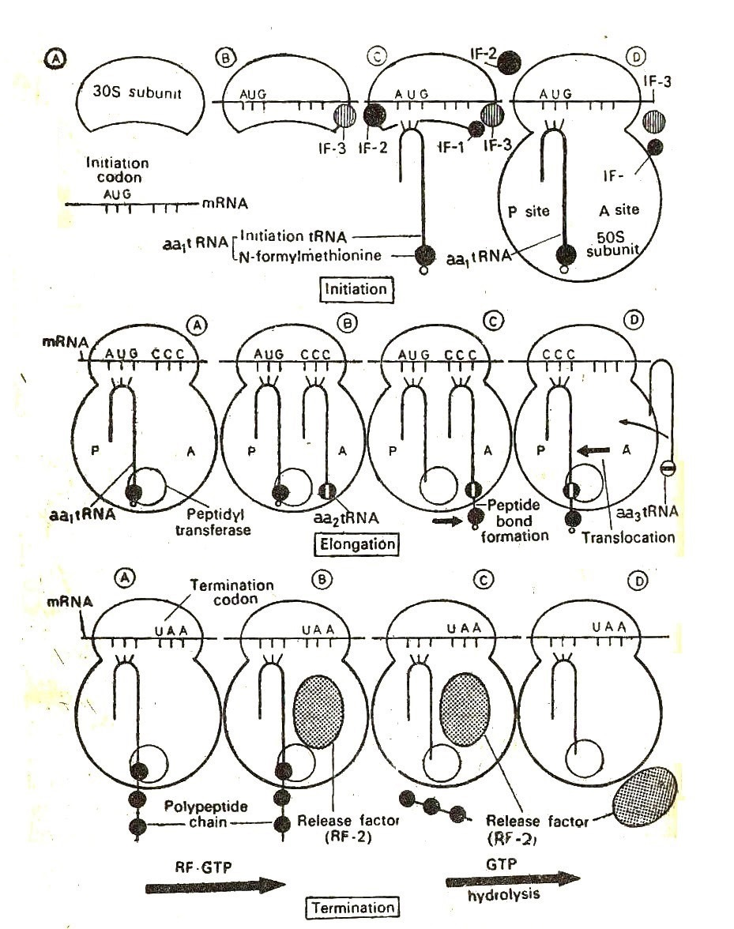

**Figure: Different stages of Translation**

**6) Protein Chain Termination:**

Elongation of polypeptide chain continues until the termination codon on in-RNA is reached. The termination codon may be UAA (ochre) UAG (amber) or UGA (opal). These codons are also called also called non-sense codons.

Even after termination the polypeptide chain remains found to the t-RNA. The termination codon provides signals to the ribosomes for attachments of release factors. In prokaryotes, there are three release factors, RF-1, RF-2 & RF-3.

RF-1: Recognize the termination codons UAA & UAG.

RF-2: Recognize the termination codons UAA & UGA.

RF-3: It stimulates the binding and release of RF-1 &RF2 from the ribosome. Thus release factors recognize termination codons, terminate protein synthesis and release polypeptide chain.

The release factors interact with peptidyltransferase causing hydrolysis of polypeptide chain at P-site. This result in cleavage and release of the chain from the t-RNA molecule at the P site. The residual t-RNA is now discharged from P site. The ribosome dissociate into it’s30S and50S subunits. In prokaryotes there is no requirement of GTP for release of polypeptide chain.

In eukaryotes a single release factor (RF) recognizes all the termination codons (UAA, UAG, UGA). RF exists as a dimer of two units. It is not clear whether the monomer or the dimer reacts with ribosome. The first step in chain termination is the binding of RF to A site containing a termination codon. This step requires GTP and activates the peptidyltransferase system. Bond present between t-RNA & polypeptides chain get hydrolysed at P site and occurs release of the polypeptide chain from ribosomes. GTP hydrolysis results in dissociation of polypeptide chain from the ribosome.

In prokaryotes the first amino acid of protein chain is N-formylmethionine**.** Many organisms have enzyme deformylase. This enzyme removes the formyl group from N-formylmethionineof synthesized protein chain. This is the processing of polypeptide chain.

**Differences between Eukaryotic & Prokaryotic Protein Synthesis**

|  |  |
| --- | --- |
| **Prokaryotic Protein Synthesis** | **Eukaryotic Protein Synthesis** |
| In Prokaryotes , protein synthesis is carried out by 70S ribosomes with smaller 30S and larger 50S subunits | In eukaryotes, protein synthesis is carried out by 80S ribosome with smaller 40S and larger 60S subunits |
| In Prokaryotes , translation begins while mRNA is being transcribed on DNA | In Eukaryotes, after transcription, the mRNA goes out through the pores in nuclear envelop to the cytoplasm where translation takes place on the ribosomes. Thus mRNA is not translated in association with DNA. |
| Many bacterial mRNA is polycistronic and mRNA has several initiation and termination sites. | Eukaryotic mRNA is monocistronic and have only single functional site for the initiation of protein synthesis. |
| May have many start sites and SD sequences all along the mRNA.  In prokaryotes starting amino acid is N-formylmethionine.  Initiation codon is usually AUG, occasionally GUG or UUG. | May have only one start site and located on 5’ end of the mRNA.  In eukaryotes starting amino acid methionine.  Initiation codon is AUG occasionally GUG or CUG. |
| Kozak sequence absent in mRNA.  In prokaryotes three initiation factors, IF-1, IF-2, and IF-3 are required for polypeptide chain initiation. | Kozak sequence present in mRNA which is located few nucleotide upstream of start site.  In eukaryotes there is no equivalent of IF-1 and there are many more factors involved i.e. eIF1 and eIF2. |
| In prokaryotes the elongation factors EF-Tu, EF-Ts and EF-G. | In eukaryotes the factors EF-1 and EF2, of which EF-1 correspond to prokaryotic EF-Tu+ EF-Ts and EF-2 corresponds with EF-G. |
| In prokaryotes the release factors are RF-1  (For termination codons UAA and UAG), RF-2 (for UAA and UGA) and RF-3 with stimulatory activity. | In eukaryotes a single release factor eRF recognizes the three termination codon. |
| In prokaryotes transcription and translation are not coupled processes. | In eukaryotes, transcription and translation are not coupled processes |
| Post transcriptional modifications of proteins takes place in cytoplasm to make protein functional. | Post transcriptional modifications of proteins takes place ER OR GC or in cytoplasm. |

**Amino acid Catabolism**

Some bacteria and fungi particularly pathogenic, food spoilage and soil microorganisms can use proteins as their source of carbon and energy.

Intact proteins cannot cross bacterial plasma membrane, so bacteria must produce extracellular enzymes called proteases and peptidases that break down the proteins into amino acids, which can enter the cell.

Generally, the first step in the breakdown of amino acids is the separation of the amino group from the carbon skeleton .The carbon skeletons resulting from the deaminated amino acids are used to form either glucose or fats, or they are converted to a metabolic intermediate that can be oxidized by the citric acid cycle. Most of the amino groups of surplus amino acids are converted into urea.

In humans, plant proteins may not be entirely adequate to support normal metabolism. This is because plants and humans require a different distribution of amino acids. In addition, the cellulose content of plants frequently inhibits digestion and absorption of the plant protein. Dietary proteins are degraded by digestive proteases, beginning in the stomach and continuing in the small intestine. The small peptides and free amino acids are then absorbed by the intestinal cells and transported in the blood to the tissues.

Amino acids are needed for the synthesis of proteins and other biomolecules. The excess amount of amino acids, in contrast with glucose and fatty acids, cannot be stored; nor are they excreted. Rather surplus amino acids are used as metabolic fuel.

Pathways leading to amino acid degradation are quite alike in most organisms. As is the case for sugar and fatty acid catabolic pathways, the processes of amino acid degradation converge on the central catabolic pathways for carbon metabolism. However, one major factor distinguishes aminoacid degradation from the other catabolic processes. In amino acid catabolism, amino groupof amino acid is separated from the carbon skeleton and shunted into the specialized pathways for amino group metabolism.

In all organisms free amino acids are not stored. Therefore, amino acid breakdown occurs whenever amino acid levels exceed requirements for synthetic processes. In mammals, the liver is the principal site of amino acid metabolism, but other tissues, such as the kidney, the small intestine, muscles, and adipose tissue also take part.

**Catabolism of amino acids**

Although each amino acid follows its own specific metabolic pathway, a few general reactions are found to be common in the catabolism of nearly all the amino acids. Most of the amino acids are converted to a-keto acids by the removal of nitrogen in the form of ammonia which is quickly transformed into urea or it gets incorporated into some other amino acids.

The general reactions of amino acids include deamination, transamination and decarboxylation

1.**Deamination**

Removal of amino group from the amino acids as ammonia is known as deamination.

**There are two types of deamination** of amino acids**:**

1. Oxidative deamination

a. NAD+- or NADP+-linked deamination

b. FAD- or FMN-linked deamination

2. Nonoxidative deamination

**1. Oxidative deamination**

Oxidative deamination is accompanied by oxidation and is catalysed by specific amino acid oxidases (dehydrogenases) present in liver and kidneys.

The process of oxidative deamination takes place in two steps.

The first step is oxidation (dehydrogenation) of amino acid resulting in the formation of imino acid. The imino acid then undergoes the second step namely hydrolysis which results in a keto acid and ammonia. The first reaction is catalyzed by amino acid oxidase (also called dehydrogenase) and the coenzyme FAD or FMN takes up the hydrogen. There are two types of amino acid oxidases depending upon the substrate, on which they act, namely,

1. L-amino acid oxidases which act on L-amino acids (FMN acts as coenzyme).

2. D-amino acid oxidases which act on D-amino acids (FAD acts as coenzyme).

FMN occurs only in the liver and kidney and FAD occurs in all animal tissues.

L-amino acid oxidase: This enzyme is present in the liver and kidney. It is anaerobic dehydrogenase that needs FMN as a coenzyme. It deaminates most of the naturally occurring L-amino acids.

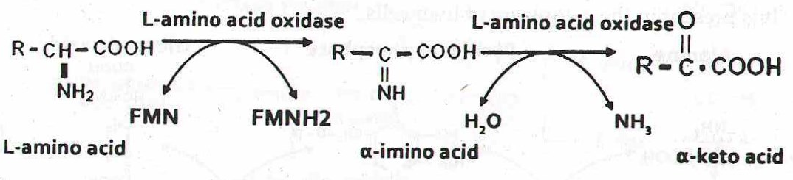

D-amino oxidase: This enzyme possesses FAD that to help promote the conversion (oxidation) of glutamate to alpha -ketoglutarate and ammonia and thus in process the oxygen gets reduced to H2O2. They are present in plants and bacterial cell wall.

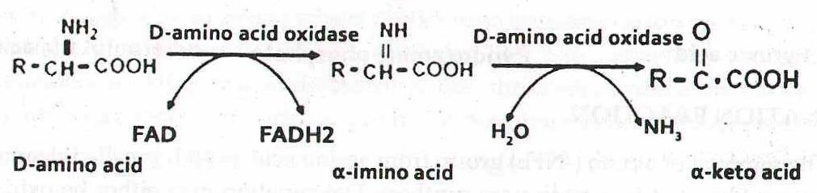

The major site of oxidative deamination is liver but kidney and other tissues also have a role.

2. **Non-oxidative deamination:**

Removal of amino group as free ammonia from amino acids without undergoing oxidation is known as nonoxidative deamination. Nonoxidative deaminases are aspartic acid deaminase (aspartase), serine, and threonine deaminases (dehydratases), and cysteine desulfhydrase.

Serine deaminases (dehydratases) catalyze the following type of reaction:

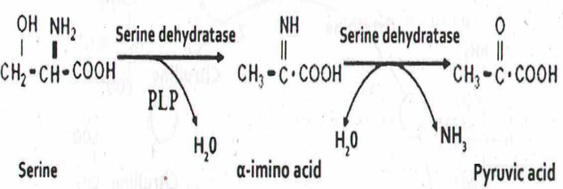

1. **Transamination**

The process of transfer of an amino group from an amino acid to an alpha -keto acid, resulting in the formation of a new amino acid and keto acid is known as transamination.

The reaction is catalysed by the enzyme transaminase. Coenzyme required is pyridoxal phosphate (PLP).

Generally three keto acids participate in this reaction. They are—(1) Pyruvate (2) alpha -ketoglutarate and (3) Oxaloacetic acid.

1. **Decarboxylation**

This refers to the removal of CO2 from the carboxyl group of amino acids. The removal of CO2 needs the catalytic action of enzymes decarboxylases and the pyridoxal phosphate coenzyme. The enzymes act on amino acids resulting in the formation of the corresponding amines with the liberation of CO2.

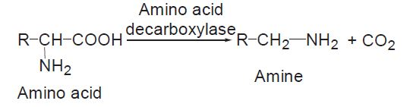

1. **Transmethylation**

The transfer of methyl group from one compound to another is called transmethylation and the enzymes involved in the transfer are known as transmethylases.

Transfer of methyl group usually involves methionine (amino acid containing methyl group). By this process various important, physiologically active compounds such as epinephrine, creatine, thymine and choline are synthesised in the body.

Methionine is a principal methyl donor. It has to be activated by ATP which requires a methionine activation enzyme of liver, known as methionine adenosyl transferase. By the action of this enzyme, methionine is converted to active methionine.

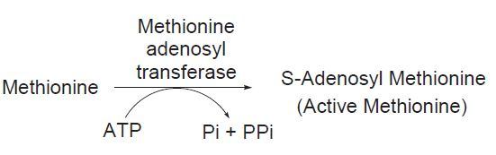

**Urea Cycle (Krebs-Henseleit cycle) – Production of Urea**

**Introduction**

In mammals, ammonia produce in metabolism of amino acids is toxic to the body. Hence, if it is not reused to synthesise amino acids or other nitrogen containing compounds, it is excreted out of the body as urea. This process of formation of urea occurs via the urea cycle. The urea once produced is excreted out by the kidneys in the urine. Urea is called carbamide and when dissolved in water has a neutral pH. The amino acid L - ornithine is converted into different intermediates before being regenerated at the end of urea cycle. Hence urea cycle is called ornithine cycle. The enzyme ornithine tanscarbamoylase catalyses the key step in urea cycle. The first two reactions occurs in the mitochondria, while last three reactions occur in cytosol. Some aquatic species which excrete ammonia directly into the surroundings which get diluted with water and are called ammonotelic species.

**Urea cycle**

Ammonia is converted to urea in the Hepatocytes of the liver in five steps via urea cycle. In the mitochondria (first two steps) and cytosol (last 3 steps).The urea then travels through the blood stream to kidney and is excreted in urine. The urea cycle was discovered by Hans Kreb’s (Who discovered Kreb’s cycle) and his student associate Kurt Henseleit in 1932. Urea cycle is discussed in detail as follows:

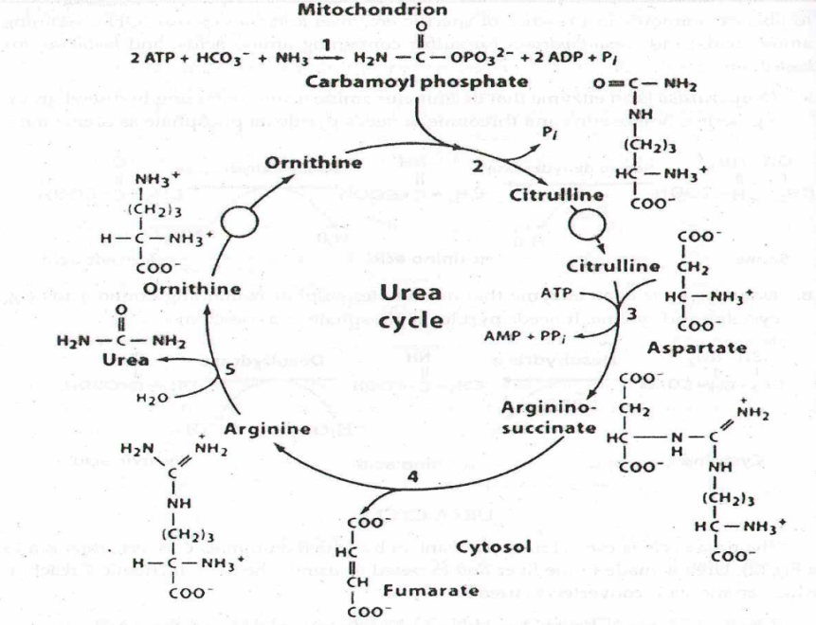

**Figure: Urea Cycle**

**Steps of Urea Cycle**

#### 1. Formation of Carbamoyl Phosphate:

#### Condensation of ammonium ion with bicarbonate ion results in the formation of carbamoyl phosphate by the enzyme carbamoyl phos­phate synthase-I present in the liver mitochondria. It requires Mg2+ , biotin and a dicarboxylic acid i.e. N-acetyl glutamate. This step requires 2 ATPs.

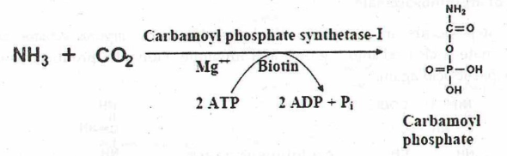

**2. Synthesis of citrulline**:

Carbamoyl phosphate formed in the first step combines with ornithine resulting in the synthesis of citrulline. The reaction is catalysed by the enzyme citrulline synthase or ornithine transcarbamoylase. Citrulline is easily permeable to the mitochondrial membrane and hence it diffuses into the cytosol of the liver cells.

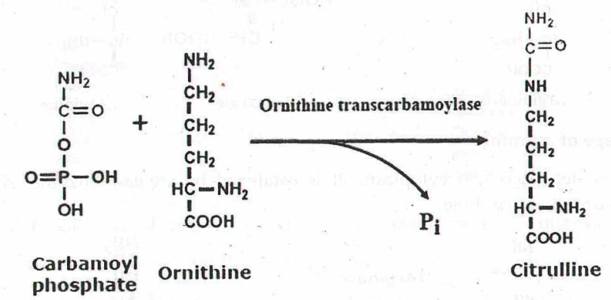

**3. Synthesis of Argininosuccinate:**

In the cytosol, citrulline combines with the aspartate forming argininosuccinate catalysed by the enzyme argininosuccinate synthase. It requires ATP which is hydrolysed to AMP resulting in utilization of two high energy bonds. Mg2+ acts as cofactor.

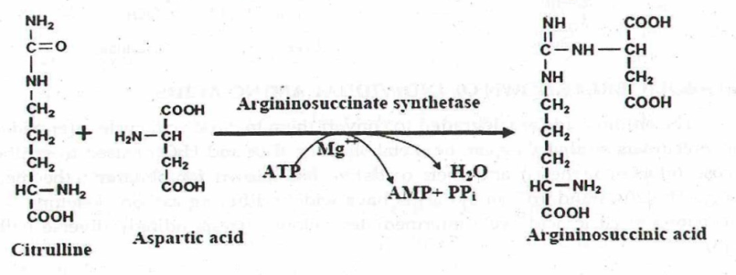

#### 4. Cleavage of Argininosuccinate:

Arginosuccinase catalyses the cleavage of arginosuccintae to give arginine and fumarate in a reversible manner. Fumarate formed here joins the citric acid cycle forming a link between urea and citric acid cycle (the linkage between TCA and urea cycle is known as Krebs bi-cycle).

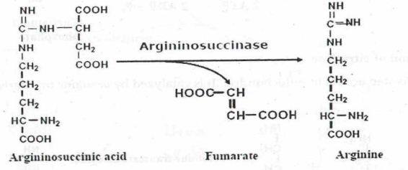

#### ****5. Cleavage of Arginine:****

Arginine is lysed into ornithine and urea under the influence of the enzyme arginase. Hence arginine is known as semi-essential amino acid i.e. though it is synthesized in the body it is not available for protein synthesis. Ornithine is regenerated in this step and the urea cycle completes by the formation of urea. Arginase is also present in testis, renal tubules, mammary gland and skin in minute quantities.

The intermediate amino acids formed in the urea cycle i.e. ornithine, citrulline and argininosuccinate are known as non-protein amino acids

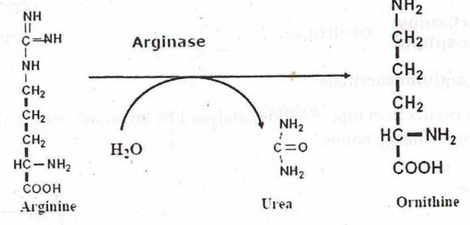

The urea cycle brings two amino groups and HCO3 together to form urea. Thus toxic, insoluble ammonia is converted into non-toxic, water soluble, extractable urea. Hence, urea cycle disposes two waste products i.e. NH4 and HCO3. This fact suggests that urea cycle participates in the regulation of blood pH, which depends on the HCO3/H2CO3. Though 3 ATPs are utilized, the ultimate cost of making a molecule of urea is 4 ATPs (one ATP is converted into AMP). The rate limiting steps of urea cycle are 1, 2, & 5.

**Energetic of Urea Cycle**

On considering only the urea cycle, and not considering the other biopathways linked, to produce one urea molecule 4 ATP molecules are used up as shown below:

NH4+ ions to Carbamoyl phosphate- utilization of 2ATP

Citrulline to arginosuccintae- breakdown of 1 ATP to AMP + PPi which is equivalent to 2 Pi.

Therefore the entire reaction can be summarized as follows:

2NH4+ + HCO3– + H2O + 3ATP → Urea + 2ADP + 4Pi + AMP + 2H+

The deamination of amino acids produces ammonia which is toxic. By this cycle it is converted to urea, a nontoxic compound. Two molecules of ammonia and one molecule of CO2 are converted to urea for each turn of the cycle.

**Metabolic breakdown of individual amino acids**

Amino acid catabolism is critically important. There are two reasons for this:

1. Amino acids are a potential source of energy especially during fasting.
2. Incomplete metabolism of a number of amino acids results in accumulation of toxic amino acid breakdown intermediates.

Amino acids are generally divided into two classes.

**Glucogenic**:

Glucogenic are amino acids with a carbon skeleton that can be converted to a TCA cycle intermediate. These amino acids can be used to synthesize glucose.

**Ketogenic**:

Ketogenic are amino acids with acarbon skeleton that can only be converted to acetyl CoA, to acetoacetyl-CoA, or to acetoacetate. The ketogenic amino acids are a potential source of ketone bodies (hence the name “ketogenic”), but cannot be used to synthesize glucose.

**QUESTIONS**

**Descriptive Questions:**

1. Discuss the salient features of genetic Code.
2. “Genetic code is triplet”. Justify the statement
3. Explain Wobble hypothesis
4. Justify “Genetic code is degenerate and non overlapping”
5. Describe the Process of Translation.
6. Explain the peptidyl transferase reaction
7. Write note on deciphering of genetic code
8. Describe Urea cycle
9. Explain the steps involved in Urea cycle.
10. Give an account on glucogenic and ketogenic amino acids

**Objective Questions:**

1. What is ambiguous code?
2. What is degeneracy of code?
3. Who discovered Genetic Code?
4. When GUG acts as initiation codon?
5. What do you mean by Sense Codon?
6. Name the termination codons in the order of discovery.
7. What are nonsense codons?
8. Name the first amino acid incorporated during translation.
9. What is the role of Initiation factors?
10. What is the role of Peptidyl Transferase?
11. Define translocation.
12. What are release factors?
13. What are Glucogenc amino acids?
14. What are ketogenic amino acids?
15. What is meant by formylation of methionine?
16. Define transamination.
17. What are ketogenic and glucogenic amino acids ?